Inertia and Equilibrium W.S.
Refer to the following information for the next two questions.

1. An astronaut in outer space away from gravitational or frictional forces throws a rock.

- The rock will .

gradually slow to a stop | continue moving in a straight line at constant speed

- The rock's tendency to do this is called
.

inertia | weight | acceleration

Refer to the following information for the next question.

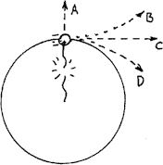
- The sketch shows a top view of a rock being whirled at the end of a string in a clockwise direction.

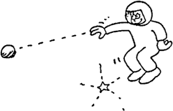

a. If the string breaks, the path of the rock is
.

A | B | C | D

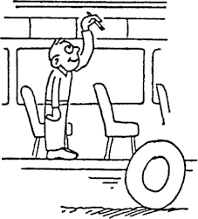
Refer to the following information for the next five questions.
- Suppose you are standing in the aisle of a bus that travels along a straight road at 100 km/h, and you hold a pencil still above your head.
  - Then relative to the bus, the velocity of the pencil is 0 km/h, and relative to the road, the pencil has a horizontal velocity of
,

less than 100 km/h | 100  km/h | more than 100 km/h

  - Suppose you release the pencil. While it is dropping, and relative to the road, the pencil still has a horizontal velocity of
.

less than 100 km/h | 100  km/h | more than 100 km/h

  - This means that the pencil will strike the floor at a place directly .

behind  you | at your feet below your hand | in front of you

  - Relative to you, the way the pencil drops
.

is the same as if the bus were at rest | depends on the velocity of the bus

  - How does this example illustrate the law of inertia?
Refer to the following information for the next three questions.

4. Use the words mass, weight, and volume to complete the table.

The force due to gravity on an object
.
The quantity of matter in an object
.
The amount of space an object occupies .

Refer to the following information for the next three questions.

- Different masses are hung on a spring scale calibrated in newtons. The force exerted by gravity on 1 kg = 9.8 N
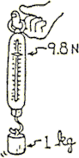
- The force exerted by gravity on 3 kg is
.

- The force exerted by gravity on 20 kg equals .

- Make up your own mass and show the corresponding weight. The force exerted by gravity on kg = N.

Complete the following table based on the object's description.

Object | Mass | Weight
1-kg melon
1-N apple
16.3 N book
120-kg Mr. Lindsay

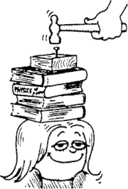
- Why isn't the girl hurt when the nail is driven into the block of wood?

- Would this be more dangerous or less dangerous if the block were less massive? Explain.

Refer to the following information for the next six questions:

- Little Nellie Newton wishes to be a gymnast and hangs from a variety of positions as shown. Since she is not accelerating, the net force on her is zero. This means the upward pull of the rope(s) equals the downward pull of gravity. She weighs 400 N.
Enter the scale reading in newtons for each case:

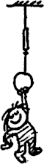 | 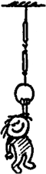 | 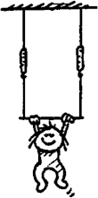
A | B | C
Scale | Scale Scale | Scale Scale

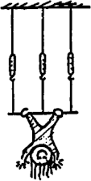 | 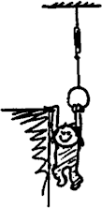 | 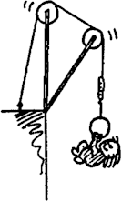
D  Scale Scale Scale | E  Scale | F  Scale

Refer to the following information for the next four questions.

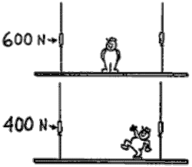
- When Adolf the painter stands in the exact middle of his staging, the left scale reads 600 N.

  - When he is standing in the middle, the reading on the right scale would be .

  - This tells us that the total weight of Adolf and staging must be .

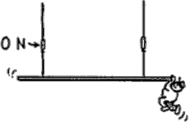
  - Adolf now stands farther from the left. The reading on the right scale would be .

  - In a silly mood, Adolf dangles from the right end. The reading on the right scale would be .

Refer to the following information for the next question.

10. The rock hangs at rest from a single string. Only two forces act on it, the upward tension T of the string, and the downward pull of gravity W.

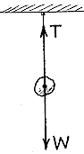
a. The forces are equal in magnitude and opposite in direction. Net force on the rock is .

zero | greater than zero
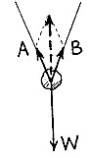
Refer to the following information for the next question.

11. Here the rock is suspended by 2 strings. Tension in each string acts in a direction along the string. We'll show tension of the left string by vector A, and tension of the right string by vector B.
a. The resultant of A and B is found by the parallelogram rule, and is shown by the dashed vector. Note it has the same magnitude as W, so the net force on the rock is .

zero | greater than zero
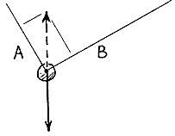
Refer to the following information for the next question.

12. Consider strings at unequal angles. The resultant A + B is still equal and opposite to W, and is shown by the dashed vector. Construct the appropriate parallelogram to produce this resultant. Show the relative magnitudes of A and B

a. Tension in A is the tension in B.

less than | equal to | greater than
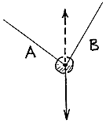
Refer to the following information for the next question.

13. Repeat the procedure for the arrangement shown below.
a. The tension is greater in rope .

A | B

Refer to the following information for the next six questions.

14. The heavy ball is supported in each case by two strands of rope. The tension in each strand is shown by the vectors. Use the parallelogram rule to sketch the resultant of each vector pair on your papers. Then describe your answers in the blanks provided.
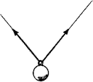

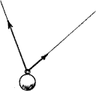

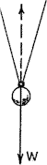
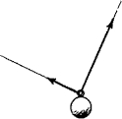

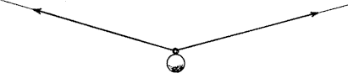

- Is your resultant vector, R, the same for each case?

- How do you think the resultant vector compares to the weight, W, of the ball?

[Now let's do the opposite of what we've done above. More often, we know the weight of the suspended object, but we don't know the rope tensions. In each case below, the weight of the ball is shown by the vector W. Each dashed vector represents the resultant, R, of the pair of rope tensions. Note that each is equal and opposite to the vector W (they must be; otherwise the ball wouldn't be at rest).]

Refer to the following information for the next four questions.

15. On your papers, construct parallelograms where the ropes define adjacent sides and the dashed vectors are the diagonals. Next, draw rope-tension vectors, clearly showing their relative magnitudes. Describe your answers in the blanks provided.
a.

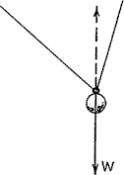

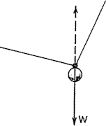

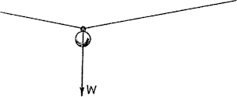

  - How do the relative lengths of the sides of each parallelogram compare to rope tensions?

- Is it possible to have motion without a force? Explain.

- Can you actually isolate or find the inertia of a body? Explain.

- Suppose you are standing on an icy surface (very little friction) and a heavy object and a light object of the same size and shape are also on the ice. How could you tell which object is heavier without picking them up?

- An old parlor trick involves suddenly pulling a tablecloth from underneath a setting of plates and glasses. Rather than falling to the floor and breaking, the plates and glasses remain on the table. Explain the “magic” of this trick.

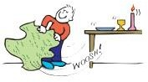
- An astronaut in a spaceship and in a “weightless” condition wants to know which of two identical containers used to store equipment is empty without opening them?

- When a paper towel is torn from a roll on a rack, a jerking motion teares the towel better than a slow pull. Why is this? Does this method work better when the roll is large or when it is small and near the end of the roll? Explain.

- A passenger in a car struck from behind sometimes experience “whiplash,” which results from the upper vertebrae of the spine being bent backward. What caused this?

- Common safety devices in automobiles are seat belts and shoulder straps. Explain why these devices are needed in terms of Newton’s first law.

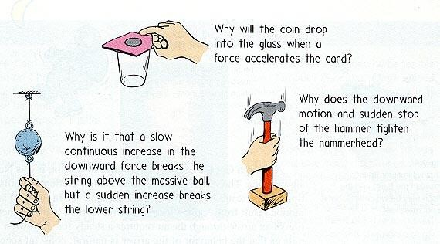
- 24.
- If a large rhinoceros was chasing you, its enormous mass and speed would be very threatening. But if you zigzagged, the rhino’s mass would be to your advantage. Why?

- REVIEW: A car has an oil drip. As the car moves, it drips oil at a regular rate, leaving a trail of spots on the road.

Which of the following diagrams of the car’s trail of spots shows the car continuously slowing down?

- In the cabin of a jetliner that cruises at 600 km/hr, a pillow drops from an overhead rack into your lap below. Since the jetliner is moving so fast, why doesn’t the pillow slam into the rear of the compartment when it drops? What is the horizontal speed of the pillow relative to the ground and you? How does this relate to you sitting in the classroom?

